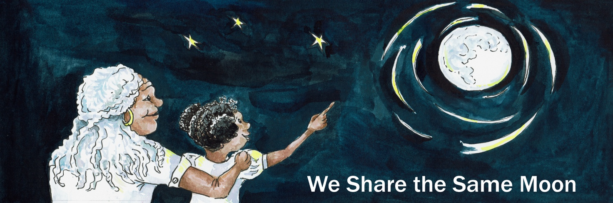

Suggested Age Range: 3 - 4 years: 4 - 5 years
Suggested UK Year Group: EYFS Nursery: EYFS Reception
UK Curriculum: EYFS
UK EYFS Curriculum Link : Understanding the World
Science Subject: Surface of the Moon
Science Question: What can you see on the Moon?
Suggested Science Activity: Cosmic Craters; Moon Globes
Children with SEND: Use with children with speech and language disabilities
EAL children: Beginners level
Country of Origin: Bolivia
Source: When Jaguars Ate the Moon by Maria Cristina Brusca and Tona Wilson

Long ago in the country called Bolivia …

There was a mountain, a big mountain that went up and up and up and up into the sky. And at the bottom of the mountain there was a tiny hole.
And in that hole, there lived a very special animal, Skunk.
Now Skunk, he has black and white stripes and a long bushy tail
And when he is scared … Eugh! he lets out a very bad smell!
Now Skunk, he sleeps all day., But - when the Moon rises at night, whoosh,
The light shines into his hole and wakes him up.
He climbs out of his hole, climb, climb, climb, climb, climb!
And looks up at the Moon “Hello Moon!”.

Now, Skunk loves the Moon very much, because when the Moon shines, he can see to find his food. When the Moon shines, Skunk, he looks and looks and looks and looks and sees. “Ahah! Berries! Yum, Yum! Yum, Yum!”
He walks and walks and walks and walks. And picks and picks and picks and picks.
And eats and eats and eats and eats. ”Yum Yum Yum Yum!”
Then the Moon begins to set and the Sun begins to rise, whoosh. And so he knows that it is time to go home and sleep. So he walks and walks and walks and walks back home.
“Thank you Moon!”. He climbs into his hole, climb, climb, climb, climb, climb.
“Good-night Moon!”And curls up and goes to sleep.

Now this he does every night, night after night after night after night,
Skunk, he loves to look at the Moon. And he sees something very curious ….
The Moon changes shape every night! Sometimes it is big and round! And then it turns into the shape of a banana! And other times - it disappears from the sky!
Where does the Moon go? And then, the Moon re-appears and gets bigger and bigger and bigger and bigger once again! Skunk, he loves looking at the Moon - because it looks so different every night

One night Skunk, has an idea - ting! “I know! I know! I know!
I will go and visit the Moon and thank her for the light”
“But how will I travel to the Moon?”
He thinks for a while, “Hmmm” When he has thought for a while.
He has an idea - “ting!” “I know ! I know! I know! I will walk to the Moon!”

So he starts to walk:

I am going to walk, walk, walk to the Moon. I am going to walk, walk, walk to the Moon.
I am going to walk, walk, walk to the Moon. I am going to walk, walk, walk to the Moon.

And walks and walks and walks and walks all night long.
But does he reach the Moon? No! The Moon is too far away!
Oh …. Skunk is very disappointed.
The Moon begins to set and the Sun begins to rise, whoosh.
He knows it’s time to turn around and walk back home.

I am going to walk, walk, walk back home. I am going to walk, walk, walk back home
I am going to walk, walk, walk back home. I am going to walk, walk, walk back home

And he climbs into his hole, climb, climb, climb, climb, climb! "Good-night Moon!”
And curls up and goes to sleep

But, the next night, he climbs out of his hole, climb, climb, climb, climb, climb!
“Hello Moon!” And he has an idea - ting!
“I know, I know, I know!” “I will ask a friend to help!”
So he looks and looks and looks and looks and sees a friend, Horse!
“Horse - will you help me to reach the Moon?" And Horse says “Yes!”

So, Skunk climbs onto Horse’s back and they start to gallop

We are going to gallop, gallop, gallop to the Moon.
We are going to gallop, gallop, gallop to the Moon.
We are going to gallop, gallop, gallop to the Moon.
We are going to gallop, gallop, gallop to the Moon.

And they gallop and they gallop and they gallop and they gallop - all night long.
But do they reach the Moon? No! The Moon is too far away!
Oh…. Skunk is very disappointed.
The Moon begins to set and the Sun begins to rise, whoosh.
They know it is time to turn around and go back home!

We are going to gallop, gallop, gallop back home.
We are going to gallop, gallop, gallop back home.
We are going to gallop, gallop, gallop back home.
We are going to gallop, gallop, gallop back home.

“Thank you Horse!” And Skunk climbs into his hole, climb, climb, climb, climb, climb! “Good-night Moon!”And curls up and goes to sleep.

But, the next night, he climbs out of his hole, climb, climb, climb, climb, climb!
And he has an idea - ting! I know! I know! I know! I will ask another friend to help!
So he looks and looks and looks and looks and sees another friend, Bear!
“Bear, will you help me climb the Mountain so I can reach the Moon?”
And Bear says “Yes!” So, Bear picks him up and they start to climb up the Mountain.

We are going to climb, climb, climb to the Moon.
We are going to climb, climb, climb to the Moon.
We are going to climb, climb, climb to the Moon.
We are going to climb, climb, climb to the Moon.

And they climb and climb and climb and climb until they reach the top of the Mountain.
And there is the Moon above! Skunk reaches up and up and up and up.
But can he touch the Moon? No! The Moon is too far away!
Oh …. Skunk is very disappointed
The Moon begins to set and the Sun begins to rise, whoosh.
And so they know it is time to turn around and go back home.

We are going to climb, climb, climb back home.
We are going to climb, climb, climb back home.
We are going to climb, climb, climb back home.
We are going to climb, climb, climb back home.

“Thank you Bear!” And Skunk climbs back into his hole, climb, climb, climb, climb, climb.
“Good-night Moon!” And curls up and goes to sleep.

But, the next night, Skunk climbs out of his hole, climb, climb, climb, climb, climb.
“Hello Moon!” And he has another idea - ting!
"I know! I know! I know! I will ask another friend to help!”
So, he looks and looks and looks and looks and he sees Owl.
"Owl! Will you help me to reach the Moon?” And Owl says “Yes!”

So Skunk climbs onto Owl’s back and together they begin to fly

We are going to fly, fly, fly to the Moon. We are going to fly, fly, fly to the Moon.
We are going to fly, fly, fly to the Moon. We are going to fly, fly, fly to the Moon.

The Owl and the Skunk they fly and fly and fly and fly and closer and closer and closer
Skunk stretches and stretches and stretches and he touches the Moon!
“Thank you Moon. Thank you for the Light!”
He gently strokes the Moon with his paw. "I love you Moon”

But, it is very cold up there in the Sky. Owl says “It is too cold up here. We must go home.” So they turn around, and begin to fly back home.

We are going to fly, fly, fly back home. We are going to fly, fly, fly back home.
We are going to fly, fly, fly back home. We are going to fly, fly, fly back home.

“Thank you Owl”.
And Skunk climbs back down his hole, climb, climb, climb, climb, climb.
“Good-night Moon!”And curls up and goes to sleep/
Happy now that he has finally reached the Moon.
And so he lived, happily ever after.

Now in the country of Bolivia, where this story is from.
They say that the dark patches that you can see on the Moon,
these were made from the Skunk’s paw as he stroked the Moon that night.
But, Scientists say that it was rocks that long ago hit the Moon,
that made the dark patches you see today
But, what do you think is true?

The End

Retold by Cassandra Wye
Copyright: April 2019

